WireShark DNS

1. 174.35.30.156
2. cam.ac.uk nameserver = dns1.cl.cam.ac.uk

cam.ac.uk nameserver = dns0.cl.cam.ac.uk

cam.ac.uk nameserver = authdns0.csx.cam.ac.uk

cam.ac.uk nameserver = dns0.eng.cam.ac.uk

cam.ac.uk nameserver = ns2.ic.ac.uk

cam.ac.uk nameserver = authdns1.csx.cam.ac.uk

1. UPD
2. The destination port for the query is 56764 and the port of response is 5355
3. The DNS query message is sent 224.0.0.252 and it is not the same the IP address from the one on the cmd command 4.31.198.44
4. The type of DNS query is A (Host address)
5. There is one answer in the DNS response message. It contains name, type, class, type, Date, and Address.
6. Before retrieving any image, my host does not provide any DNS query.
7. The destination port of the DNS query is 50990 and the source port is domain 53
8. The DNS query message is sent to 75.75.75.75 which is the same as the default local DNS server
9. The DNS query message has no answer at all
10. The DNS response message contain 3 answer. They contain name, type, class, time, data length, primaryname.

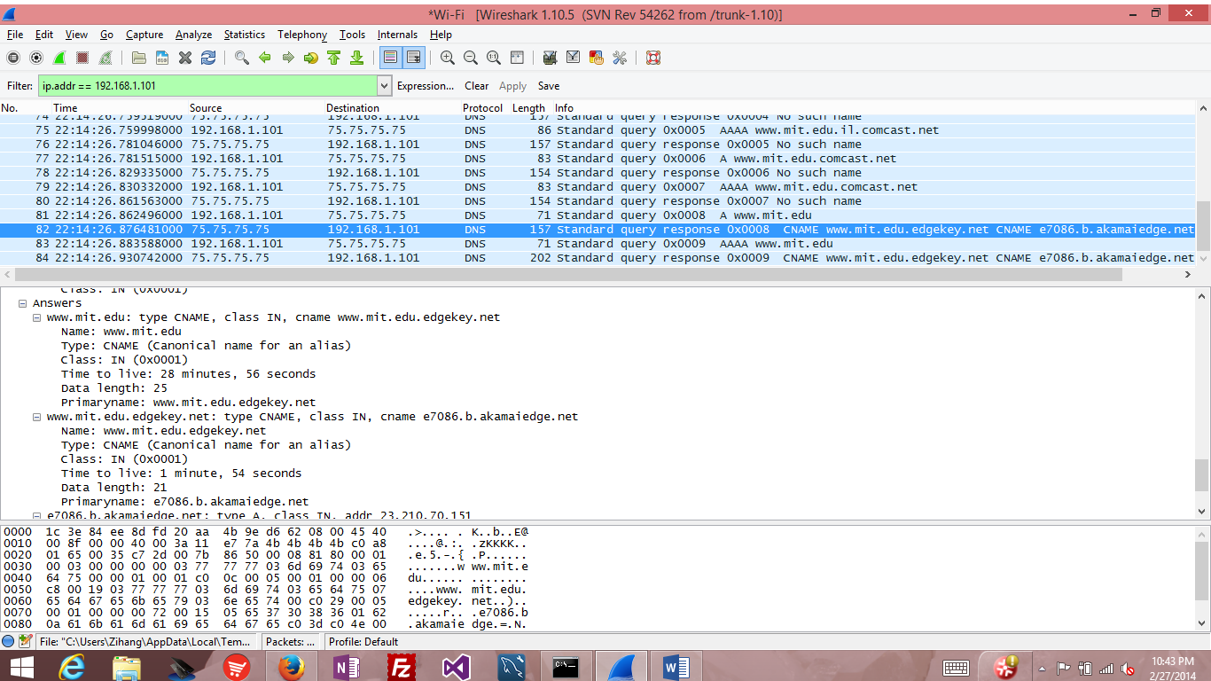

1. The DNS query message is sent to 75.75.75.75 which is the same as the default local DNS server
2. The type of the DNS query is AAAA (IPv6 address) and it does not contain any answer
3. The primary nameserver is use2.akam.net, but it does not provide the IP address of this server

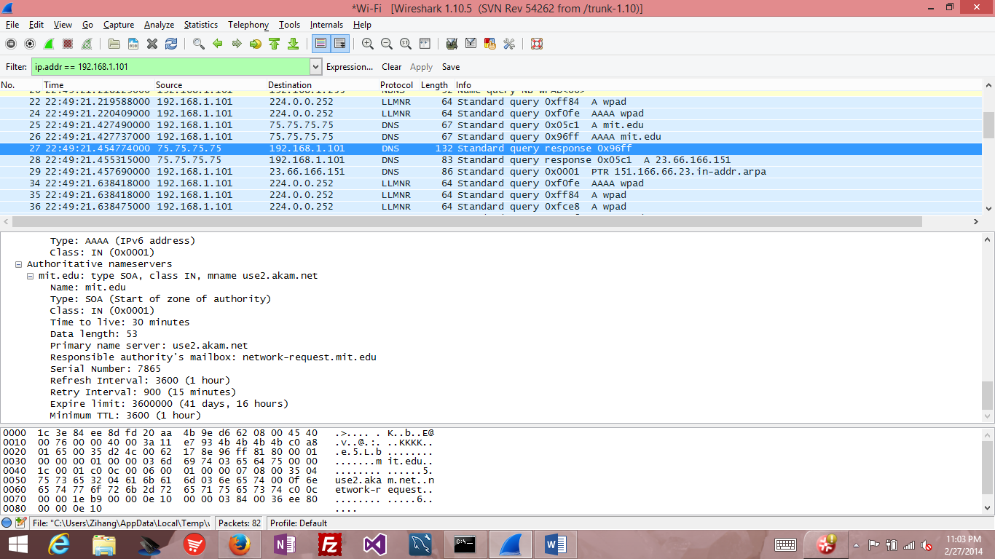

1. The DNS query message is sent to 18.72.0.3 which different from the default local DNS server. It corresponds to [www.aiit.or.kr](http://www.aiit.or.kr)
2. The type is AAAA (IPV6 Address) and it provide no answer.
3. There is no response message

